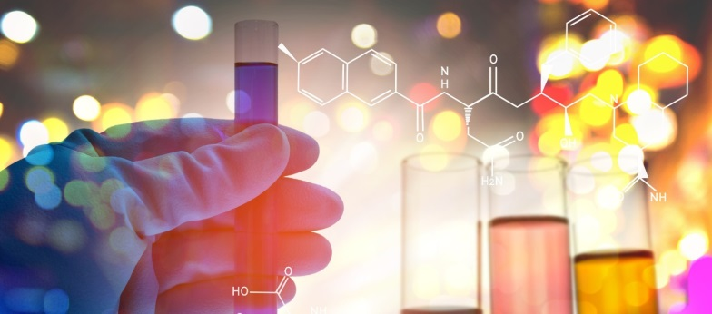
Newsflash No. 1
October 2016

Introduction

The European chemical industry is currently facing strong competitive pressure from the United States, Asia and the Far East. High costs, demanding regulations and company restructuring are threatening traditional production and existing employment in Europe.
We believe in a world, where chemical innovation provides solutions to societal challenges like climate change, aging population, energy transition and resource scarcity.
In that world, chemical companies are highly innovative and develop new products and processes in cooperation with upstream industries to grow new markets and ensure sustainable workplaces in Europe.
The S3Chem Project ensures that regional public funding is provided to companies and research entities to enable the implementation of innovation and R&D projects.
That’s why chemical regions are working together to jointly develop better policies for innovation promotion in the chemical sector.
Available funding for innovation promotion
The Regional Innovation Strategies in the partner regions have allocated considerable amounts of financial resources until 2020: The operational Programme of the ERDF Objective 1b provides the structural framework. Several Funding instruments are available for innovation promotion, R&D cooperation, patent support and others. Chemical related innovations play an important role and companies and research institutes can access part of this funding.

Analysis of implementation of Regional Innovation Strategies in Chemical Regions
The project partners have completed an analysis of the implementation of Regional Innovation Strategies with focus on chemical related topics. The report contains a description of the partner regions and their chemical sector. A summary of the Regional Innovation Strategies (RIS) with special attention to the innovation priorities for chemical related topics including bioeconomy is provided. Furthermore, the partners describe the general funding framework of the European Regional Development Fund (ERDF) in each region. A special chapter is dedicated to the governance of the RIS, the established structures and networks and the relevant stakeholders from industry and academia in the chemical sector. The analysis draws conclusions on the challenges for the implementation of RIS in the coming years. Due to the late start some delays in the spending of budgets have occurred, which must be compensated. Partners are very interested in how to develop technology roadmaps in order to identify promising innovation topics for funding projects. The efficient implementation of innovation funding is very important. A special question is how to provide access for SME to innovation support. All partners want to use the S3Chem project to initiate international or bilateral cooperation on innovation topics of common interest.
Download of Analysis: https://www.interregeurope.eu/s3chem/library/
Site Visit to Brightlands Chemelot Campus in Limburg
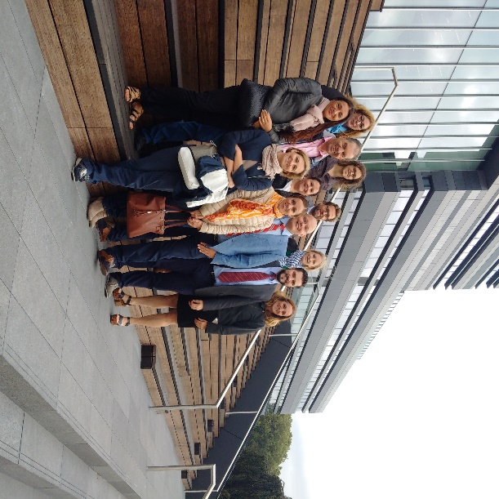
The project partners have organised a site visit to the Brightlands Chemelot Campus on 28 September 2016. The Province of Limburg in cooperation with large chemical companies like DSM and the Maastricht University will invest 100 Million Euro in a 10-year plan to build up the Campus. 90 new companies could be settled in the chemical park since 2015, where about 6000 people are working. The Chemelot Campus is home of 74 companies, that employ 1730 people. Until 2023 2900 employees should work here. Furthermore 660 students are present in the Campus to study their chemical related subjects in close cooperation with the local companies. The project partners were impressed by the dynamic development and were discussing cooperation potential between companies and research institutes in the partner regions.
More Information: www.brightlands.com/brightlands-chemelot-campus

Contact:
Smart Chemistry Specialisation Strategy
www.interreg-europe.eu/S3Chem

